Fixed Play Equipment in Schools – Adornments and Additions

A key area of the British/European Standard BS EN1176-2020 is the design out of any points capable of causing the entrapment of a child using the equipment.

It is important that the equipment should not be altered, modified or interfered with in any way which might result in a “hidden” entrapment risk being introduced. An example of this is tying ropes, bunting or flags onto an item which may encroach into Free Space and/or create a point of potential entrapment within an area of forced movement. The use of cable ties to attach educational items such as alphabet letters or animal pictures to the outside of an item can give rise to entrapment areas where a child can trap fingers or clothing.
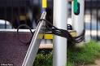

The dimensions of possible entrapment points are carefully specified and measured using standard sized probes which prevent children getting bodies, heads, legs, feet, arms, hands, fingers, hair or clothing trapped in narrow gaps on the equipment. This is especially important on items such as slides etc. where once committed to the movement the child cannot suddenly stop to release the entrapment. However, entrapment with potential fatal consequences can occur on any item.

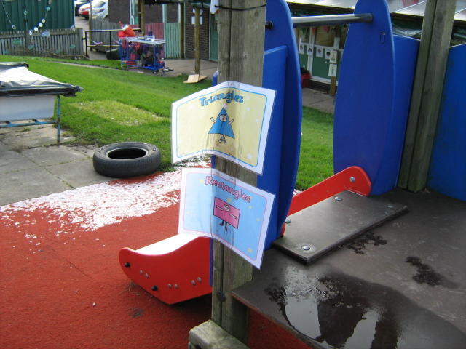 Stapling items onto the frame of wooden equipment can also cause serious issues if the staples are not fully removed and are allowed to break or rust in the timber leaving sharp protrusions often at head height to a child.

It is vital that all staff supervising or involved in sessions which include items of fixed play equipment, whether on controlled premises or in the local park, are aware of the concepts of entrapment and understand why the British/European Standard is in place. Attention should be drawn to the sad case at York College Nursery in 2012 where a three-year-old child was killed as a result of an entrapment incident involving a rope which had been tied onto the frame of a slide.

Reviewed January 2022

